Wandering spleen in children: splenic loss is associated with delay rather than technique, and a reinforced two-pole splenopexy is described
Jun Shu¹, Jun Yang¹, Hongqiang Bian¹, Fei Peng¹, Ji Wang¹
¹ Department of General Surgery, Wuhan Children’s Hospital (Wuhan Maternal and Child Healthcare Hospital), Tongji Medical College, Huazhong University of Science & Technology, Wuhan 430016, Hubei, China
Corresponding author: Jun Yang, Department of General Surgery, Wuhan Children’s Hospital, Wuhan 430016, Hubei, China. E-mail: yjun201602@163.com
Abstract
Purpose Wandering spleen is a rare paediatric condition in which deficient splenic suspensory ligaments permit migration of the spleen and torsion of its vascular pedicle. Both the determinants of splenic loss and the optimal method of splenopexy remain poorly defined. We reviewed a single-centre series to examine these questions and to describe a reinforced two-pole fixation technique.
Methods The records of all children managed surgically for wandering spleen at our institution between May 2015 and May 2026 were reviewed retrospectively. Demographic, clinical, laboratory, imaging, operative and follow-up data were extracted and analysed descriptively.
Results Five children (two girls, three boys; 2.75–13.08 years) accounted for ten institutional encounters. Four had at least one earlier symptomatic episode that did not lead to splenic surgery: in three the family declined the recommended operation and surgery followed a mean of 32 months later, and one had been treated as acute gastritis elsewhere a week before presentation. Four of the five lost the spleen — three to total splenectomy for infarction or necrosis, and one after an initial capsular splenopexy recurred within a month. The child treated by reinforced two-pole fixation retained a viable, normally sited spleen at 13 months. One child had established necrosis despite a normal preoperative platelet count.
Conclusion In this series splenic loss was associated with delay rather than any deficiency of technique, and splenopexy should be performed once the diagnosis is made. A normal platelet count does not exclude necrosis.
Keywords Wandering spleen · Splenic torsion · Splenopexy · Splenectomy · Children

What is Known:
• Wandering spleen is a rare cause of abdominal pain in children and may progress to pedicle torsion and splenic infarction; splenic preservation is preferred while the parenchyma remains viable.
• Preoperative thrombocytosis has been reported to predict splenic infarction in children with splenic torsion.
What is New:
• Across five children, splenic loss was associated with the delay between the first symptomatic episode and definitive surgery, not with the operative technique chosen; four of five spleens were lost after delays of one week to sixty-two months.
• A normal preoperative platelet count did not exclude established necrosis in hyperacute torsion, and full-thickness two-pole fixation buttressed with haemostatic gauze salvaged a spleen after a capsular splenopexy had failed.
Introduction
Wandering spleen is an uncommon condition in which the gastrosplenic, splenorenal and phrenicocolic ligaments are absent or deficient, leaving the spleen suspended on a narrow vascular pedicle and free to migrate within the abdomen [1, 2]. It is rare in childhood, and the paediatric literature consists almost entirely of single case reports and series of two or three patients [3, 4]. Because the spleen is tethered only by its pedicle, it is vulnerable to torsion, which compromises arterial inflow and venous drainage and may progress through congestion and ischaemia to infarction [5]. Torsion may also involve adjacent structures, producing gastric volvulus, torsion of the pancreatic tail, or compression of hollow viscera [6, 7, 8].
The clinical presentation is notoriously non-specific. Chronic intermittent abdominal pain, attributed to partial or intermittent torsion, alternates with episodes of acute severe pain, and affected children are frequently investigated and treated for other causes of abdominal pain before the diagnosis is reached [9]. Ultrasonography and computed tomography (CT) are diagnostic once the possibility is entertained, but the condition must first be suspected.
Where the parenchyma remains viable, splenic preservation is now preferred to splenectomy, given the immunological consequences of asplenia and the risk of overwhelming post-splenectomy infection [3, 10]. Several splenopexy techniques have been described — wrapping the spleen in absorbable or synthetic mesh, constructing a retroperitoneal or subperitoneal pouch, suturing the splenic capsule to the diaphragm and abdominal wall, or a sutureless button-and-hole fixation — but each has recognised limitations, and failures are reported [11-14]. Which technique should be preferred, particularly for the enlarged spleen or after a failed fixation, remains unsettled.
Two questions are therefore of practical importance: what determines whether the spleen is saved, and how fixation should be performed when the conventional approaches are not feasible. We reviewed eleven years of experience at a single paediatric centre and describe a reinforced two-pole fixation technique developed after a conventional capsular splenopexy failed within the same series.
Methods
Study design and population
We retrospectively reviewed the records of all children treated surgically for wandering spleen at Wuhan Children's Hospital between 1 May 2015 and 1 May 2026. Wandering spleen was defined as an abnormally mobile spleen displaced from its normal left-upper-quadrant fossa on ultrasonography or computed tomography, with or without torsion of the vascular pedicle. Children in whom the diagnosis was made but who never underwent splenic surgery were not included. The study was approved by the institutional ethics committee (2025R156-E01); because the data were collected retrospectively and no identifiable information is reported, the requirement for individual informed consent was waived.
Data collection
Demographic characteristics, presenting symptoms and their duration, physical findings, laboratory results, imaging findings, operative details and postoperative course were extracted from the medical records. Where a child attended more than once, each encounter was recorded separately so that the interval between the first presentation and definitive splenic surgery could be determined. Platelet counts were recorded at every encounter.
Outcomes and follow-up
The primary outcome was splenic salvage, defined as retention of a viable, normally positioned spleen at the most recent assessment. Secondary outcomes were recurrence of splenic migration after fixation and the recognised complications of splenectomy — overwhelming post-splenectomy infection, arterial or venous thromboembolism, and pulmonary hypertension. Follow-up was by outpatient review and telephone interview; splenic position and perfusion were assessed by abdominal ultrasonography or contrast-enhanced CT at intervals after operation.
Analysis
Given the small number of patients, data are reported descriptively and no formal statistical comparison was undertaken.
Results
Patients
Five children were identified, two girls and three boys, aged 2.75 to 13.08 years at first presentation (Table 1). Together they accounted for ten encounters at our institution. Abdominal pain, alone or with vomiting or distension, was the presenting complaint at every encounter, and ultrasonography or CT established the diagnosis before operation in all five children.
Course before definitive surgery
Four of the five children had at least one earlier symptomatic episode that did not lead to splenic surgery. In Cases 1, 2 and 3 the diagnosis was made at the first presentation and operation was recommended, but the families declined and elected conservative management with fluid resuscitation, gastrointestinal decompression and postural measures. Symptoms settled on each occasion, after five to seven days, and the children were discharged. All three were subsequently re-admitted with recurrent pain and came to splenic surgery a mean of 32 months after their first presentation, at 16, 19 and 62 months respectively; Case 3 attended four times over more than five years before her first splenic operation. Case 5 had been admitted to another hospital one week before presentation and managed there as acute gastritis. Only Case 4 underwent operation at his first presentation, and then because of a coexisting gastric perforation.
Splenic loss
Four of the five children ultimately lost the spleen. Cases 1 and 2 had developed pedicle torsion with established infarction by the time of their second presentation and underwent total splenectomy, by laparotomy and by laparoscopy converted to laparotomy respectively (Fig. 1). In both the preoperative platelet count was elevated, at 428 and 525 × 10⁹/L.
Case 5, a boy of 13 years, presented 18 hours after the onset of continuous periumbilical pain with guarding, generalised tenderness and a palpable mobile mass. The white cell count was 24.20 × 10⁹/L and the C-reactive protein 117 mg/L, but the platelet count was normal. Non-contrast CT showed an enlarged, irregular spleen lying in the anterior lower abdomen and pelvis with heterogeneous parenchymal density, a whirl sign formed by the spiralling splenic vessels, perisplenic fat stranding, splenic vessels encircling the splenic flexure of the colon, and free fluid. At laparotomy 2.5 hours later the pedicle was twisted through approximately 720°; the spleen was congested and dark purple and did not reperfuse after detorsion. Total splenectomy with separate double ligation of the splenic artery was performed. The operative time was 81 minutes and the blood loss 10 mL. He remains well at the most recent follow-up, 5 months after operation.
Case 3 illustrates the failure of conventional fixation. By her third attendance, 62 months after her first presentation, CT showed a wandering spleen measuring 17.3 × 7.6 cm with partial infarction (Fig. 2). At laparoscopy the infarcted parenchyma was resected and a subperitoneal pouch was fashioned through a longitudinal incision in the left upper quadrant peritoneum, but the spleen proved too large to be accommodated within it. The upper pole was therefore sutured to the diaphragm and the lower pole to the lateral peritoneum with 5-0 silk, with Hem-o-lok clips applied to augment the fixation. CT one week after operation confirmed a normally sited spleen with the clips in position at both poles (Fig. 3). One month later she was re-admitted with abdominal pain; CT showed recurrent migration, the spleen measuring 16.6 × 7.6 cm, with anteromedial rotation of the body and tail of the pancreas (Fig. 4). Total splenectomy was performed, the resected spleen being divided into 3-cm slices and implanted within the greater omentum.
Splenic salvage and the reinforced two-pole technique
Case 4, a boy of 2 years and 9 months, presented with two hours of abdominal distension. Non-contrast CT showed marked gastric distension with wandering spleen and pedicle torsion, and contrast-enhanced CT performed 1.5 hours later demonstrated free intraperitoneal and pelvic fluid with gastrointestinal perforation and gastric volvulus; the spleen measured 8.4 × 3.7 cm and enhanced uniformly, and the pancreas lay anterior and to the right of the stomach. At emergency laparotomy the stomach had rotated about its mesenteric axis with cephalad displacement of the pylorus and duodenum; after reduction, a 2-cm perforation on the posterior wall of the antrum was identified and repaired. The spleen lay in the left mid-abdomen, held only by its pedicle, and was viable.
The spleen was returned to the left upper quadrant and fixed as follows (Fig. 5). Absorbable haemostatic gauze was laid on both the visceral and the diaphragmatic surface of the upper pole. A 2-0 non-absorbable silk suture was passed through the gauze on the visceral surface, through the full thickness of the splenic parenchyma, and out through the gauze on the diaphragmatic surface; it was then passed through the diaphragmatic muscle, back through the gauze on the diaphragmatic surface and the full thickness of the parenchyma, and tied on the visceral surface. The lower pole was secured to the left lateral abdominal wall in the same manner. He recovered without incident and remains asymptomatic, with a normally positioned spleen on CT at 13 months.
Platelet counts and postoperative course
All four children who underwent total splenectomy developed postoperative thrombocytosis, which reached 918 × 10⁹/L on the ninth postoperative day in Case 5 and normalised on oral dipyridamole in every case. None developed overwhelming post-splenectomy infection, thromboembolism or pulmonary hypertension during follow-up.
Preoperative thrombocytosis preceded splenectomy in Cases 1 and 2, and at every encounter at which the spleen remained viable the platelet count lay within the normal range. Case 5 was the exception: the spleen was necrotic at operation despite a normal preoperative count.
Discussion
The central observation of this series is that splenic loss was associated with delay rather than with any deficiency of technique. Four of five spleens were lost, and in each the definitive operation was preceded by an interval during which the diagnosis was either known and not acted upon or not made at all. In Cases 1 to 3 the diagnosis was established at the first attendance and operation was recommended and declined; the children returned a mean of 32 months later, by which time two had infarcted and the third had a giant, partly infarcted spleen that could no longer be accommodated within a retroperitoneal pouch. In Case 5 the interval was one week rather than years, and the route to that delay was different — diagnostic rather than a deferred decision to operate: an episode of torsion was attributed to acute gastritis elsewhere, and by the time the correct diagnosis was made the spleen had undergone 720° torsion and was necrotic. Only Case 4, operated at his first presentation, retained his spleen, and he came to operation not because the wandering spleen was recognised as an emergency but because he had perforated his stomach.
This bears directly on the management of the child whose symptoms have settled. Conservative management is superficially attractive because the pain resolves: in this series it resolved on every occasion it was treated non-operatively, within five to seven days. That resolution is not evidence of a resolved problem. It reflects spontaneous detorsion, and the ligamentous deficiency that permitted the torsion is unchanged. The natural history in these children was of recurrent episodes culminating in infarction. Our findings therefore support splenopexy once the diagnosis is made, including in the child who is asymptomatic at the time, a position also reflected in larger multicentre and pooled-review experience [3, 12].
A corollary concerns the platelet count. Reactive thrombocytosis has been reported as a preoperative predictor of splenic infarction in children with splenic torsion [15], and our first two cases conformed: both had counts above 400 × 10⁹/L before splenectomy, and counts were normal at every encounter at which the spleen was viable. Case 5 did not conform. He had established necrosis after only 18 hours of symptoms, with a normal platelet count. We hypothesize that the explanation is temporal: reactive thrombocytosis is thought to require a period of functional asplenia long enough for the marrow to respond, and therefore may mark a subacute or chronic course rather than infarction itself, whereas in hyperacute torsion such an interval has not yet elapsed. A normal platelet count should not be used to exclude infarction or necrosis in a child with suspected torsion, and where the presentation is acute, imaging rather than haematology must decide. In that setting the whirl sign, the spiral of the twisted splenic vessels, was sufficient to establish the diagnosis on a non-contrast study in Case 5 and is worth seeking specifically [16].
The second question concerns fixation. Mesh splenopexy, in which the spleen is wrapped in absorbable or synthetic mesh anchored to the diaphragm or peritoneum, is well described and effective in appropriately sized spleens, but becomes difficult when the spleen is enlarged, both because the spleen cannot be enclosed and because laparoscopic working space is limited; synthetic material also carries risks of infection and foreign-body reaction [11, 12, 17]. Construction of a retroperitoneal or subperitoneal pouch, by balloon dilatation, saline injection or blunt dissection, is the other widely used approach [13, 18-20]. It too depends on the spleen fitting, and compression within a pouch that is too small has been reported to cause ischaemia and infarction. Where the pouch cannot be made large enough, surgeons have resorted to splenectomy, as illustrated by Case 3 below.
Case 3 followed exactly this course. The pouch could not accommodate a 17.3-cm spleen, and the fallback — approximating the splenic capsule to the diaphragm and lateral peritoneum, reinforced with clips — failed within a month. The reason, in retrospect, is that fixation of this kind depends on the capsule, which is thin, smooth and poorly suited to holding a suture against the weight of a large mobile organ.
The technique used in Case 4 was designed around that failure. Passing the suture through the entire thickness of the parenchyma rather than the capsule alone transfers load to the whole organ and does not depend on capsular integrity. The absorbable haemostatic gauze bolsters on both surfaces spread that load over an area rather than a point, which limits the tendency of the suture to cut through the parenchyma, controls bleeding at the suture sites, and promotes local adhesion between spleen, diaphragm and abdominal wall. The technique requires no prosthetic material and no retroperitoneal dissection, and, unlike mesh or pouch fixation, does not depend on the spleen fitting within a wrap or pocket — a property that should in principle extend to the enlarged spleen, although this remains to be confirmed (see below). A comparable rationale underlies the sutureless button-and-hole method, which likewise avoids reliance on the capsule alone [14].
These conclusions must be qualified. The association between delay and splenic loss described here is descriptive, not causal: the cohort comprised only children who ultimately underwent splenic surgery, so children diagnosed with wandering spleen who never came to operation are not represented, and with five patients and no statistical comparison, confounding by factors other than delay itself cannot be excluded. The technique, separately, was used in one patient and followed for 13 months, so this is a preliminary technical description and not a validated standard. The series is small, retrospective and from a single centre. Critically, the child in whom the technique succeeded had a spleen of normal size, 8.4 × 3.7 cm, whereas the circumstance that motivated the technique — the giant spleen of Case 3 — is precisely the one in which it remains untested. Whether full-thickness fixation will hold a 17-cm spleen, and whether parenchymal sutures remain secure as a child's spleen grows, can be answered only by multicentre collection with longer follow-up.
Conclusion
In this eleven-year single-centre series, splenic loss was associated with delay in reaching definitive surgery rather than with any deficiency of operative technique: four of five children came to definitive surgery between one week and sixty-two months after their first symptomatic episode, and all four lost the spleen. Splenopexy should be undertaken when the diagnosis is made, including in the child whose symptoms have settled, and a normal platelet count does not exclude necrosis in acute torsion. Reinforced full-thickness two-pole fixation buttressed with absorbable haemostatic gauze offers a simple alternative when mesh or pouch techniques are not feasible or have failed, but it requires evaluation in more patients before it can be recommended generally.
Declarations
Author contributions Jun Shu conceived the study, acquired and interpreted the data and prepared the manuscript. Fei Peng and Ji Wang drafted the manuscript. Jun Yang and Hongqiang Bian revised the manuscript critically for important intellectual content. All authors read and approved the final version.
Funding No funding was received for this work.
Data availability The datasets generated and analysed during the current study are available from the corresponding author on reasonable request.
Ethics approval This study was approved by the Ethics Committee of Wuhan Children’s Hospital (Wuhan Maternal and Child Healthcare Hospital), Tongji Medical College, Huazhong University of Science & Technology (2025R156-E01).
Consent to participate Given the retrospective nature of the study, the requirement for informed consent was waived by the ethics committee. No identifiable information is included in this report.
Competing interests The authors declare no competing interests.
References
1. Ganarin A, Fascetti Leon F, La Pergola E, Gamba P (2021) Surgical approach of wandering spleen in infants and children: a systematic review. J Laparoendosc Adv Surg Tech A 31:468–477
2. Cui Q, Xu X, Li C, Tang L (2024) Wandering spleen combined with pedicle torsion and splenic infarction: a rare case report and literature review. Front Pediatr 12:1429490
3. Fiquet-Francois C, Belouadah M, Ludot H, Defauw B, Mcheik JN, Bonnet JP et al (2010) Wandering spleen in children: multicenter retrospective study. J Pediatr Surg 45:1519–1524
4. Al Blooshi M, Aboelkheir A, Hiremath A, Jaber G, AlMarzouqi M (2025) The enigmatic wandering spleen: managing three cases in a tertiary setting. BMC Pediatr 25:631
5. Gashaw Wubie A, Yirga B, Goedert MH (2025) Splenic infarction following torsion of wandering spleen involving pancreatic tail successfully managed in a resource-limited setting: a case report. J Med Case Rep 19:41
6. Lombardi R, Menchini L, Corneli T, Magistrelli A, Accinni A, Monti L et al (2014) Wandering spleen in children: a report of 3 cases and a brief literature review underlining the importance of diagnostic imaging. Pediatr Radiol 44:279–288
7. Colombo F, D’Amore P, Crespi M, Sampietro G, Foschi D (2019) Torsion of wandering spleen involving the pancreatic tail. Ann Med Surg (Lond) 50:10–13
8. Okazaki T, Ohata R, Miyano G, Lane GJ, Takahashi T, Yamataka A (2010) Laparoscopic splenopexy and gastropexy for wandering spleen associated with gastric volvulus. Pediatr Surg Int 26:1053–1055
9. Radillo L, Taddio A, Ghirardo S, Bramuzzo M, Pederiva F, Maschio M et al (2016) The great pretender: pediatric wandering spleen: two case reports and review of the literature. Pediatr Emerg Care 32:619–622
10. Cohen O, Baazov A, Samuk I, Schwarz M, Kravarusic D, Freud E (2018) Emergencies in the treatment of wandering spleen. Isr Med Assoc J 20:354–357
11. Torri F, Parolini F, Vanzetti E, Milianti S, Cheli M, Alberti D (2015) Urgent laparoscopic mesh splenopexy for torsion of wandering spleen and distal pancreas: a case report. Asian J Endosc Surg 8:350–353
12. Alqadi GO, Saxena AK (2019) Is laparoscopic approach for wandering spleen in children an option? J Minim Access Surg 15:93–97
13. Martínez-Ferro M, Elmo G, Laje P (2005) Laparoscopic pocket splenopexy for wandering spleen: a case report. J Pediatr Surg 40:882–884
14. Zivkovic SM (1998) Sutureless “button and hole” splenopexy. Pediatr Surg Int 13:220–222
15. Wang Z, Peng C, Wu D, Wang K, Chen Y (2022) Diagnosis and treatment of splenic torsion in children: preoperative thrombocytosis predicts splenic infarction. BMC Pediatr 22:440
16. Gulati M, Suman A, Satyam, Garg A (2020) Torsion of wandering spleen and its adherence to the right ovary — an unusual cause of recurrent pain abdomen. J Radiol Case Rep 14:10–18
17. Esposito C, Settimi A, Centonze A, Damiano R, Maglio P, Esposito G (2005) Enlarged wandering spleen treated with hemisplenectomy and fixation of the residual spleen. Pediatr Surg Int 21:488–490
18. Schaarschmidt K, Lempe M, Kolberg-Schwerdt A, Schlesinger F, Hayek I, Jaeschke U (2005) The technique of laparoscopic retroperitoneal splenopexy for symptomatic wandering spleen in childhood. J Pediatr Surg 40:575–577
19. Fukuzawa H, Urushihara N, Ogura K, Miyazaki E, Matsuoka T, Fukumoto K et al (2006) Laparoscopic splenopexy for wandering spleen: extraperitoneal pocket splenopexy. Pediatr Surg Int 22:931–934
20. Umeda S, Kimura K, Takama Y, Yamauchi K, Yonekura T (2021) Laparoscopic retroperitoneal splenopexy for wandering spleen: a novel technique using a three-incision retroperitoneal pouch. Asian J Endosc Surg 14:644–647
Table 1
Clinical course and outcome of the five children with wandering spleen, by encounter. CT computed tomography, F female, M male, PC platelet count, US ultrasonography, WS wandering spleen
Case | Sex | Encounter | Age (years) | Presentation | Imaging and platelet count | Management | Outcome
1 | M | 1 | 3.75 | Abdominal pain, 2 days | US: WS, splenic perfusion preserved. PC 198 ×10⁹/L (normal) | Conservative, 5 days; operation advised but declined | Re-admitted 16 months later
1 | M | 2 | 5.08 | Abdominal pain and fever, 1 day | CT: pedicle torsion with splenic infarction. PC 428 ×10⁹/L (elevated) | Laparotomy; total splenectomy | Spleen lost
2 | F | 1 | 5.5 | Abdominal pain, 2 days | CT: pedicle torsion, no infarction. PC 125 ×10⁹/L (normal) | Conservative, 7 days; operation advised but declined | Re-admitted 19 months later
2 | F | 2 | 7.08 | Abdominal pain, 1 day | CT: pedicle torsion with splenic infarction. PC 525 ×10⁹/L (elevated) | Laparoscopy converted to laparotomy; total splenectomy | Spleen lost
3 | F | 1 | 4.5 | Abdominal pain and vomiting, 1 day | US: WS with marked gastric distension. PC 212 ×10⁹/L (normal) | Conservative, 6 days; operation advised but declined | Re-admitted 26 months later
3 | F | 2 | 6.67 | Abdominal pain and vomiting, 2 days | CT: gastric distension, WS, no infarction. PC 236 ×10⁹/L (normal) | Conservative, 5 days | Re-admitted 36 months later
3 | F | 3 | 9.67 | Intermittent abdominal pain, 9 days | CT: partial infarction; spleen 17.3 × 7.6 cm. PC 172 ×10⁹/L (normal) | Laparoscopic partial splenectomy with capsular splenopexy | Recurrent migration at 1 month
3 | F | 4 | 9.75 | Abdominal pain, 2 days | CT: recurrent migration, spleen 16.6 × 7.6 cm; pancreatic rotation. PC 152 ×10⁹/L (normal) | Laparoscopic total splenectomy with omental autotransplantation | Spleen lost
4 | M | 1 | 2.75 | Abdominal distension, 2 hours | CT: pedicle torsion, gastric volvulus, gastric perforation; spleen 8.4 × 3.7 cm. PC 177 ×10⁹/L (normal) | Laparotomy; repair of gastric perforation and reinforced two-pole splenopexy | Spleen preserved; well at 13 months
5 | M | 1 | 13.08 | Abdominal pain, 18 hours | CT: whirl sign, splenic necrosis; 720° pedicle torsion at operation. PC normal | Laparotomy; total splenectomy with splenic artery ligation | Spleen lost; well at 5 months
Figure legends
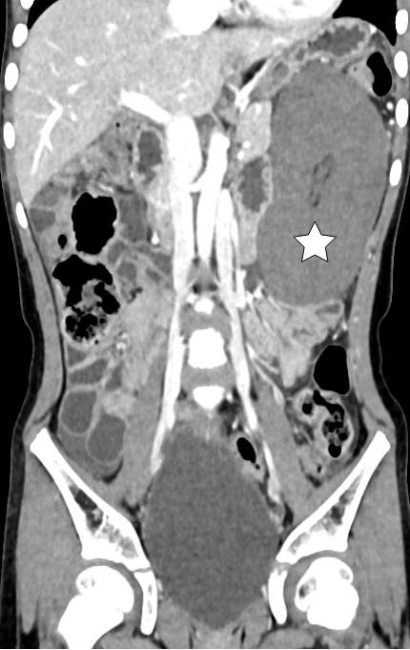
Fig. 1 CT at the second presentation of Case 2, nineteen months after the first, showing a wandering spleen with pedicle torsion and established splenic infarction (white star).
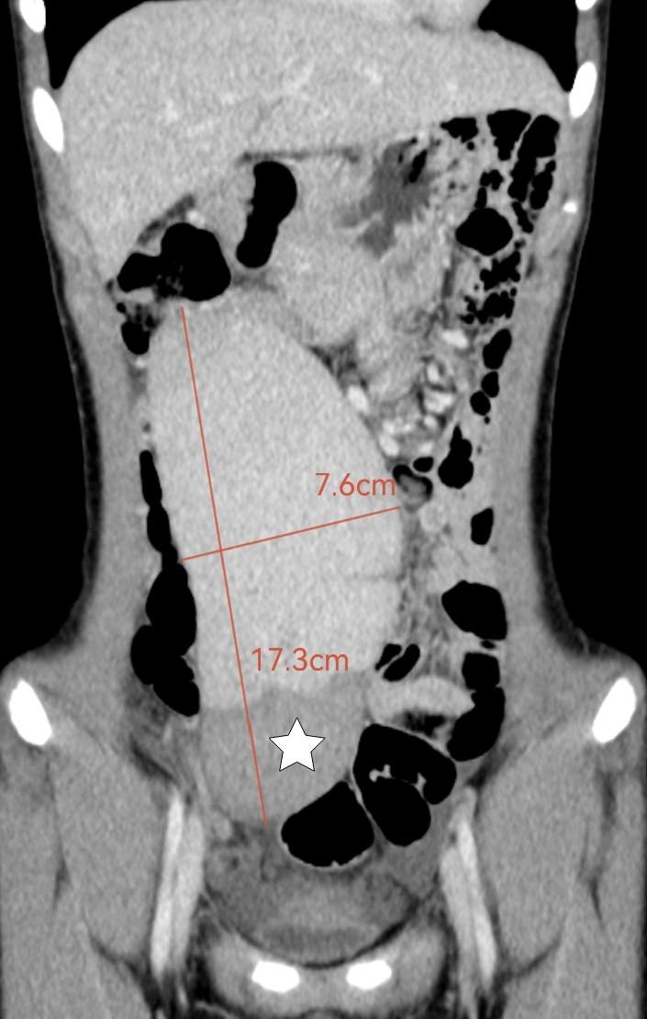
Fig. 2 CT at the third presentation of Case 3, sixty-two months after the first, showing a wandering spleen with partial infarction (white star) measuring 17.3 × 7.6 cm.
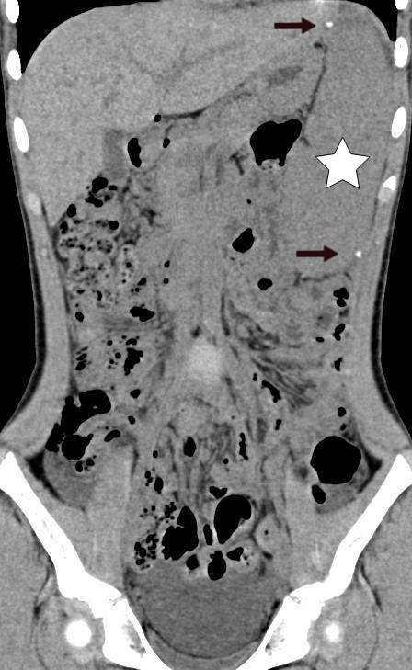
Fig. 3 CT one week after laparoscopic partial splenectomy and capsular splenopexy in Case 3, showing the spleen in a normal position (white star) with Hem-o-lok clips at the upper and lower poles (black arrow).
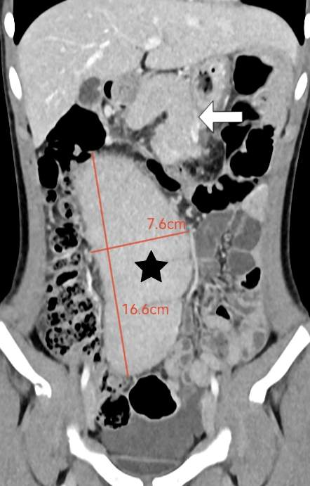
Fig. 4 CT one month after splenopexy in Case 3, showing recurrent migration of the spleen (black star), measuring 16.6 × 7.6 cm, with anteromedial rotation of the body and tail of the pancreas (white arrow).
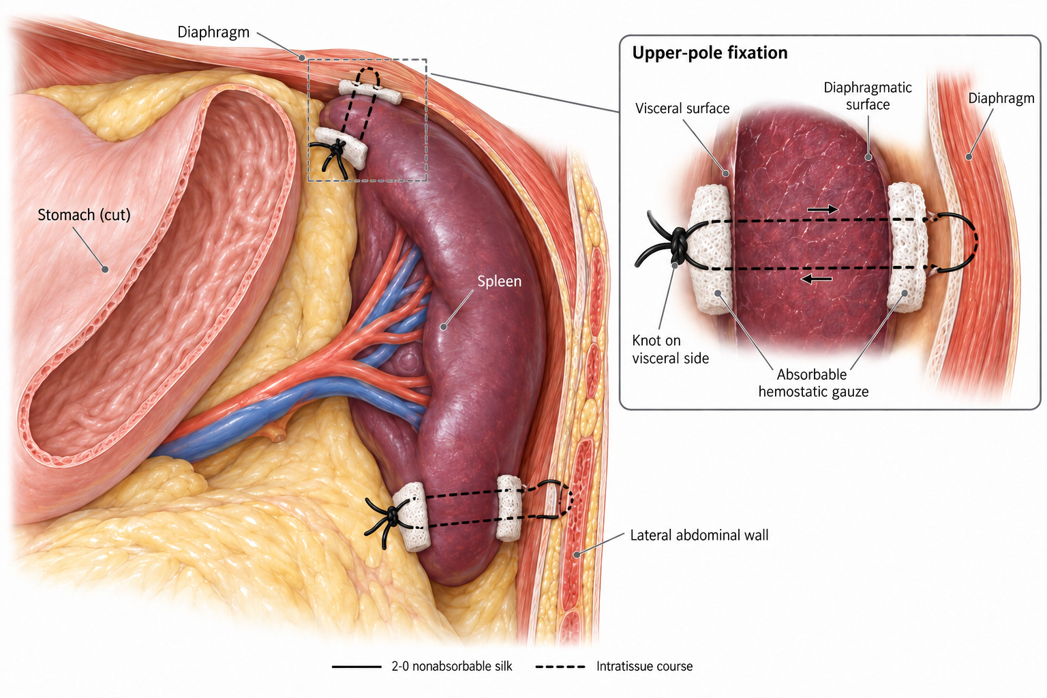
Fig. 5 Reinforced two-pole splenopexy. Absorbable haemostatic gauze is applied to the visceral and diaphragmatic surfaces of the splenic pole; a 2-0 non-absorbable silk suture is passed through the gauze and the full thickness of the parenchyma, through the diaphragmatic muscle, and back through the parenchyma, and is tied on the visceral surface. The lower pole is secured to the left lateral abdominal wall in the same way. Inset: detail of upper-pole fixation.

